User Guide
Options Page:
- To open Options page, open new tab in Chrome and type chrome://extensions and press enter.
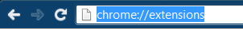
- Go to “OSN Notifications” extension and click on Options link.
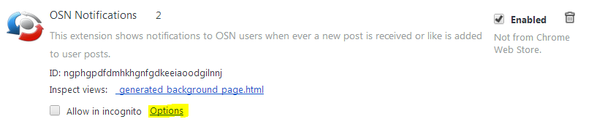
- Options page opens in new tab as shown below.
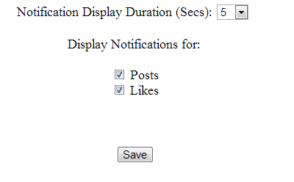

Notification Display Duration:
- To change the Notification Display Duration, select the time from the drop down and click on Save button.
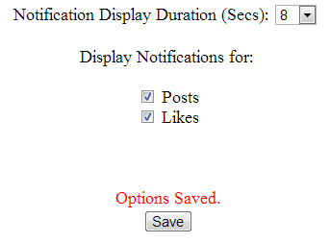
Display Notifications for events:
- Check or uncheck Checkboxes next to event names under “Display Notifications for” section. Notifications are displayed for checked events.
